Section 1: Case Summary

Scenario Title: | Local Anesthetic Systemic Toxicity Case
Keywords: | local anesthetic toxicity, lipid emulsion therapy
Brief Description of Case: | A femoral nerve block has just been performed on a 65-year-old male who sustained a right femoral neck fracture. The patient also sustained a laceration to the scalp which was repaired by the medical student. The patient is now complaining of blurry vision, paresthesias, and “twitchiness”. The patient progresses on to seizure followed by cardiac arrest and will need high quality ACLS care along with lipid emulsion therapy.

Goals and Objectives
Educational Goal: | To allow learners to identify and treat a severe overdose in a patient who received local anesthetic for a peripheral nerve block.
Objectives:  (Medical and CRM) | Medical  - Identify local anesthetic toxicity  - Provide high quality ACLS care  - Initiate lipid emulsion therapy for treatment of local anesthetic toxicity  CRM  - Manage resources to complete simultaneous investigation and treatment of an unstable patient including poison control and relevant consultants  - Delegate tasks effectively to facilitate resuscitation
EPAs Assessed: | ME 2.4 Initiate medical treatment of the patient with an overdose, toxic ingestion or  exposure, including specific antidote therapy

Learners, Setting and Personnel
Target Learners: | ☒ Junior Learners |  | ☒ Senior Learners |  |  | ☐ Staff
 | ☒ Physicians | ☒ Nurses |  | ☐ RTs | ☐ Inter-professional
 | ☐ Other Learners:
Location: | ☒ Sim Lab |  | ☐ In Situ |  |  | ☐ Other:
Recommended Number of Facilitators: | Instructors: 1
 | Confederates: 0-1
 | Sim Techs:

Scenario Development
Date of Development: | 13/10/2019
Scenario Developer(s): | Anali Maneshi & Harrish Gangatharan
Affiliations/Institutions(s): | McGill Department of Emergency Medicine, McGill Faculty of Medicine
Contact E-mail: | anali.maneshi@mail.mcgill.ca
Last Revision Date: | 2/8/2020
Revised By: | Anali Maneshi & Harrish Gangatharan
Version Number: | 2

Section 2A: Initial Patient Information

- Patient Chart
Patient Name: George Geoparodopolous |  |  |  | Age: 65 | Gender: Male | Weight: 80 kg
Presenting complaint: Palpitations and funny taste in mouth
Temp: 37.0ºC | HR: 78/min | BP: 156/78 |  | RR: 22/min | O₂Sat: 99% | FiO₂:
Cap glucose: 7.0 mmol/L |  |  |  | GCS: 15 (E4 V5 M6 )
Progress note (to be used as stem to be read to learner):
65-year-old male presents after sustaining a fall in the shower. He has a femoral neck fracture and large laceration on his scalp. A medical student has repaired his laceration. You are called to the bedside as the patient has started to complain of blurry vision, paresthesias and “twitchiness”.

Allergies: NKA
Past Medical History:  A-fib  Diabetes mellitus type II  Chronic kidney disease |  |  | Current Medications:  Warfarin  Metformin  Ramipril

Section 2B: Extra Patient Information
A. Further History
Include any relevant history not included in triage note above. What information will only be given to learners if they ask? Who will provide this information (mannequin’s voice, confederate, SP, etc.)?

Further HPI to be provided if the resident asks:
The patient just received a femoral nerve block by the staff MD 10 minutes prior.
B. Physical Exam
List any pertinent positive and negative findings
Cardio: S1, S2 but sounds irregular at times | Neuro: Alert, complaining of blurry vision, paresthesias, and “twitchiness”
Resp: GAEB, no adv sounds | Head & Neck: Scalp laceration repaired
Abdo: soft, non-tender | MSK/skin:  Cannot move left leg, but neurovascularly intact
Other: No distress but expressing anxiety about sudden change in vision

Section 3: Technical Requirements/Room Vision

A. Patient
☒ Mannequin (specify type and whether infant/child/adult)
☐ Standardized Patient
☐ Task Trainer
☐ Hybrid
B. Special Equipment Required
Gloves
Stethoscope
Defibrillator
NIBP cuff / Pulse oximeter
IV Bags/Lines
IV Push Medications
Nasal Prongs
Non-Rebreather Mask
Bag Valve Mask
Laryngoscope
ET Tubes
C. Required Medications
ACLS meds
Lipid emulsion 20%
D. Moulage
Bandage on the head. Right leg looks slightly shorter and externally rotated than the left leg.

E. Monitors at Case Onset
☐ Patient on monitor with vitals displayed
☒ Patient not yet on monitor
F. Patient Reactions and Exam
Include any relevant physical exam findings that require mannequin programming or cues from patient
(e.g. – abnormal breath sounds, moaning when RUQ palpated, etc.) May be helpful to frame in ABCDE format.

Rhythm: Normal sinus rhythm with some intermittent 1st degree blocks

Section 4: Confederates and Standardized Patients

Confederate and Standardized Patient Roles and Scripts
Role | Description of role, expected behavior, and key moments to intervene/prompt learners. Include any script required (including conveying patient information if patient is unable)
Nurse | Tells you that patient complaining of palpitations, paresthesias, and “twitchiness”

Section 5: Scenario Progression

Scenario States, Modifiers and Triggers
Patient State/Vitals | Patient Status | Learner Actions, Modifiers & Triggers to Move to Next State |  | Facilitator Notes
1. Baseline State  Rhythm: Prolonged PR on monitor  HR: 78/min  BP: 156/78  RR: 22/min  O₂SAT: 99%  T: 37ºC | Alert, complaining of blurry vision, paresthesias, and twitchiness. | Expected Learner Actions  History and physical  Monitors  Ask for med list  2nd peripheral IV  Get EKG  Ask for medications and doses given up until now and checks glucose  Verbalize differential diagnosis including local anesthetic toxicity and head injury | Modifiers  Changes to patient condition based on learner action  - If asks for lipid emulsion, will be told it needs to be prepared  - If calls poison control, will be prompted to talk to them over the phone by nurse who will get back to them  -If asks for what medications given, lidocaine by med student but not sure how much as well as bupivacaine 45mL of 0.5%  Triggers  For progression to next state  - All actions complete or 5 min into case 2. Progressive CNS toxicity
2. Progressive CNS toxicity  Rhythm: Difficult to tell due to seizure activity  HR: 120/min  BP: 180/90  RR: 40 /min  O₂SAT: 85 %  T: 37.0ºC | Patient starts seizing | Expected Learner Actions  Recognizes seizure  Lorazepam 0.1mg/kg )max 4mg) IV or midazolam 10mg IV (repeat q5mins)  Check glucose, send lab panel, consider broad differential diagnoses  Puts on high flow oxygen and considers intubation  Lipid emulsion 20% Bolus: 1 – 1.5 ml/kg over 1 min (Can repeat bolus every 3 minutes up to a total dose of 3 ml/kg) THEN  0.25 mL/kg/minute, and repeat bolus as necessary | Modifiers  - Benzodiazepines given Seizure continues  - Supplemental O2 O₂SAT: 95 %  - At 9 minutes Poison control calls back and says if seizing or cardiac arrest, give lipid emulsion 20% bolus 1-1.5 mg/kg over 1 min then infusion  Triggers  - All actions complete or 10 minutes 3. Cardiac arrest
3. Cardiac Arrest  HR: VT at 220/min  BP: 0  RR: 0/min  O₂SAT: 70%  No pulse | Patient unresponsive | Expected Learner Actions  Recognizes cardiac arrest  High quality ACLS care  Consider bicarbonate  Consider intubation  Give lipid emulsion at this point if not done already  Call ICU +/- consideration for ECMO | Modifiers  Triggers  - If does not give lipid emulsion continue ACLS until End scenario  - After lipid emulsion 4. ROSC
4. ROSC  HR: 90/min  BP: 100/70  RR: 16 /min  O₂SAT: 95%  Strong pulse | Patient moaning | Expected Learner Actions  Identify ROSC  Get EKG + full head to toe reassessment and vital signs  Give bolus 500 cc NS IV for hypotension | Triggers  - Calls ICU for transfer or after 15 minutes total End Scenario

Appendix A: Laboratory Results

Only VBG is back in time (drawn prior to seizure pH 7.4, pCO2 40, pO2 98, HCO3 24,
lactate 2.6

Appendix B: ECGs, X-rays, Ultrasounds and Pictures

Paste in any auxiliary files required for running the session. Don’t forget to include their source so you can find them later!

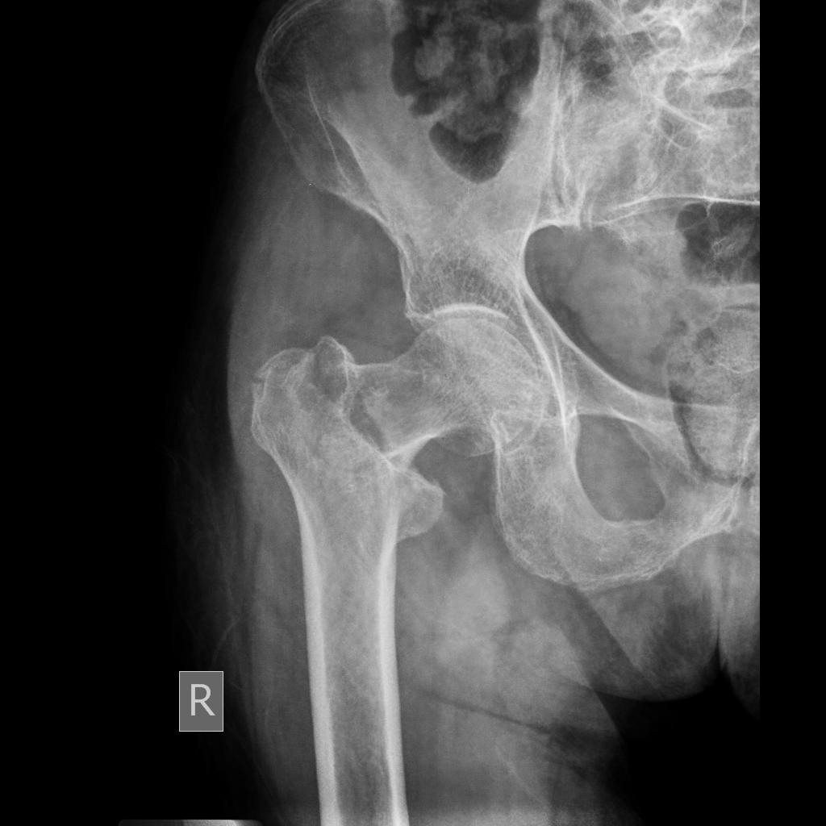

Source: https://radiopaedia.org/cases/femoral-neck-fracture-1

Appendix C: Facilitator Cheat Sheet & Debriefing Tips

Include key errors to watch for and common challenges with the case. List issues expected to be part of the debriefing discussion. Supplemental information regarding any relevant pathophysiology, guidelines, or management information that may be reviewed during debriefing should be provided for facilitators to have as a reference.

Debriefing as a group, without video.

Sample questions for debriefing:
CRM
- How can you use the team to effectively communicate with resources (e.g. poison control) while managing an unstable patient?
- How do you ensure you have gathered all the information you want while managing an unstable patient?

Medical Expert
- What are the initial symptoms of LAST? Does it differ with lidocaine vs. bupivacaine? What is the toxic dose of each of these?
- What considerations in managing seizures secondary to LAST?
- What changes in ACLS medications should be considered when managing LAST?

Key moments:
- Recognizing LAST.
- Calling poison control early.
- Giving lipid emulsion which is the definitive treatment for LAST while also providing supportive management.

References

1. LAST – REBEL EM – Emergency Medicine Blog retrieved from: https://rebelem.com/local-anesthetic-systemic-toxicity-last/
2. NYSORA Local Anesthetic Systemic Toxicity - https://www.nysora.com/foundations-of-regional-anesthesia/complications/local-anesthetic-systemic-toxicity/
3. Local anesthetic systemic toxicity: current perspectives. Retrieved from: https://www.ncbi.nlm.nih.gov/pmc/articles/PMC6087022/
4. https://emergencymedicinecases.com/status-epilepticus/

